**Supplementary results:**

Number of colonies in plate filled with water and 0.3% of agar

*Fig. 1: Number of new colonies per area over time for controls. Plates were divided in 5 areas of equal width. The average number of colonies in areas is considered as an indicator of bacterial response to nutrient gradient. The very low number of colonies on all areas suggest that no bacteria move on the plate without nutrient gradient.*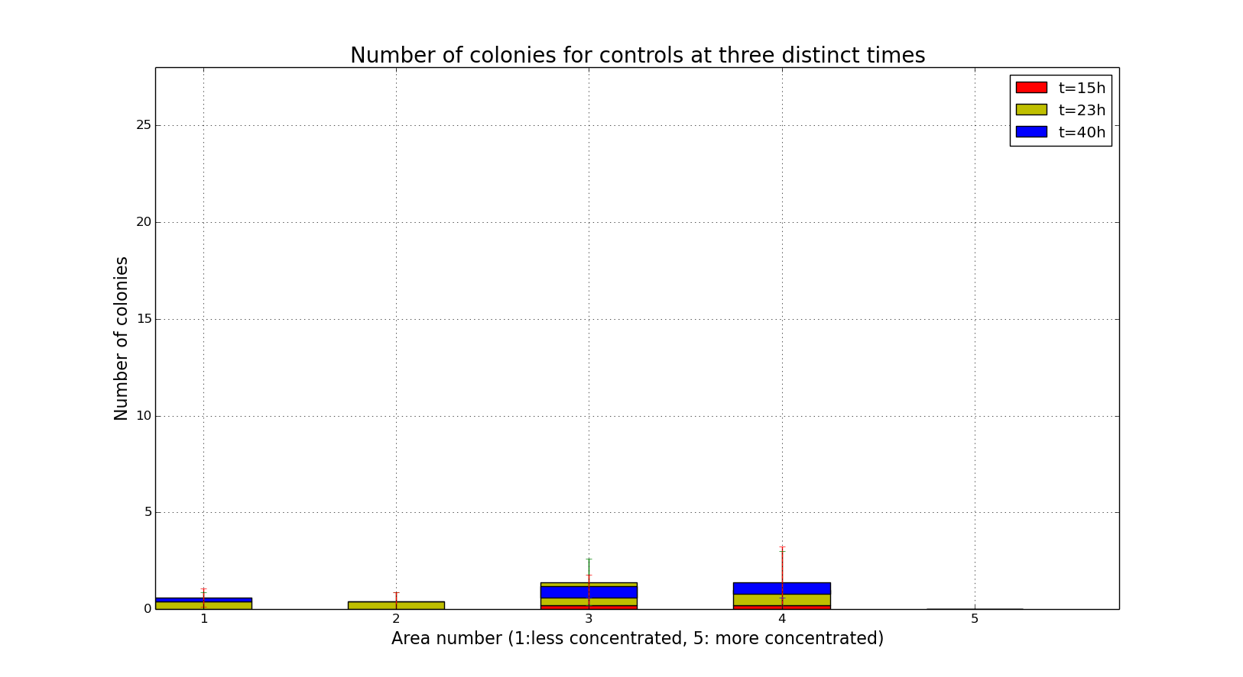

Size of colonies in plate filled with water and 0.3% of agar

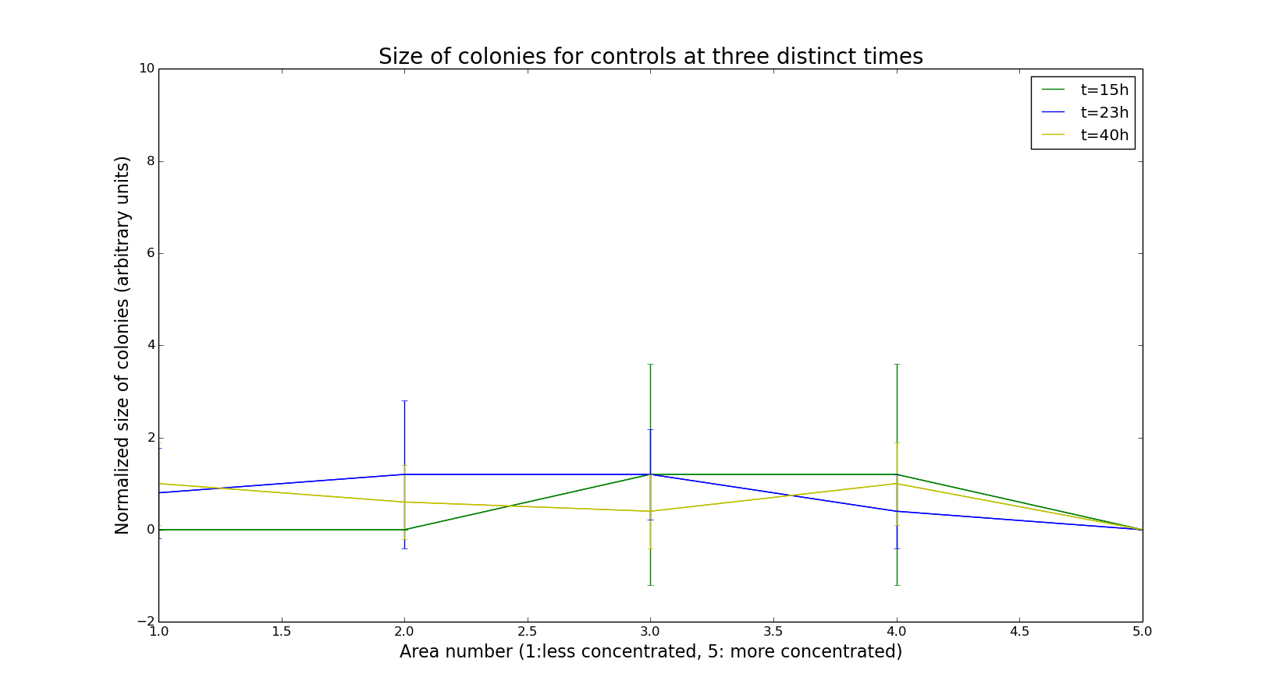

*Fig. 2: Size of colonies per area over time for controls. Plates were divided in 5 areas of equal width. The average size of colonies in areas is considered as an indicator of bacterial response to nutrient gradient. The small size of colonies in plates without nutrient gradient all along the experiment suggest that colonies absolutely need more nutrients to grow.*